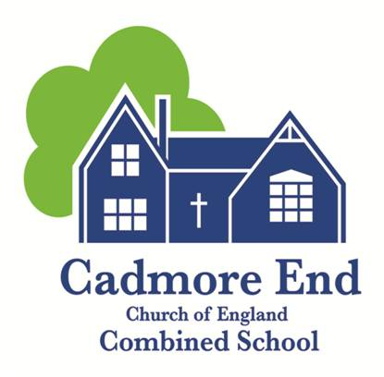
Cadmore End CofE Combined School - Person Specification

Job Title: EYFS Class Teacher
 | Essential | Desirable
Education and Qualifications
Degree | ✓
Qualified Teacher Status | ✓
Evidence of engagement in continuing professional development, including recent training in related curriculum or teaching and learning developments | ✓
Evidence of further study |  | ✓
Experience
Experience as a good / outstanding teacher | ✓
Experience in teaching EYFS | ✓
Experience in supporting improvements in teaching and learning |  | ✓
Experience in using data to inform planning and future developments | ✓
Experience in monitoring, evaluation and review to support improvements/ improved outcomes | ✓
Experience in delivering both discrete and cross curricular ICT learning opportunities | ✓
A successful track record of improving performance outcomes |  | ✓
Experience in working with children with special educational needs. | ✓
Evidence of leading on the professional development of others |  | ✓
Personal Attributes
Values aligned with the school’s Mission Statement and core values. | ✓
Ability to work as part of a team | ✓
Positive, enthusiastic outlook, embracing risk and  innovation | ✓

Self-motivated and well organised | ✓
Encourages ideas, initiative and innovation in others | ✓
Highly motivated showing resilience, stamina and reliability under pressure | ✓
Inspires respect and confidence | ✓
Reflective and keen to develop yourself and others | ✓
Ability to communicate effectively | ✓
The ability to form and maintain appropriate relationships and personal boundaries with children and young people in line with the Cadmore End Safeguarding and Child Protection Policy and the Staff Code of Conduct | ✓
Safeguarding
Cadmore End CofE Combined School is committed to safeguarding and promoting the welfare of children, young people and vulnerable adults and expects all staff and volunteers to share this commitment. The successful candidate will have to meet the person specification and will be required to apply for a DBS disclosure. We particularly welcome applicants from under- represented groups including those based on ethnicity, gender, transgender, age, disability, sexual orientation or religion.

