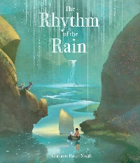
The Rhythm of the Rain – Grahame Baker – Smith
Subject | Learning Objective | Activity | Resources | How long should I spend on this?
English | LO: I can write a diary entry. | Diary of the Jar. Can you use the jar template, to recall some of the places that Isaac went and write a diary entry for a day from the story?  Think about the 5 senses – what can you see, hear, smell, taste and touch? | - Jar template – See page 3 of this document or Class 3 webpage.  - Diary entry features checklist. | 45-60 minutes
Maths | LO: I can estimate volume and capacity. | Collect different sized containers, draw them and write an estimate of how much water you can fill it with. Then fill each container with water, pour back into a measuring jug and see if you were correct.  CHALLENGE – can you covert the measurement from mm to litres? | - Measuring table worksheet – see page 5 of this document. .
Extra | LO: I can create a boat that will float on water. | Use different materials around your house to put together a boat that would float and withstand a similar journey to Isaac’s.  Feel free to follow the instructions on page 6 of this document or create your own.  Don’t forget to evaluate your boat when you have finished – see page 7 of this document for the evaluation sheet. | - Making a paper boat instructions  - Collection of everyday materials  - Cardboard  - Paper  - Recycled plastic  - Celotape  - Boat evaluation sheet
 | LO: I can create rain scape music. | Listen to the music clip on YouTube of rain sounds,  https://www.youtube.com/watch?v=buqt6_CjtuI Can you recreate these sounds using everyday home objects?  Record the music you make! | - Everyday home objects  - rice  - cereal  - jars  - wooden objects

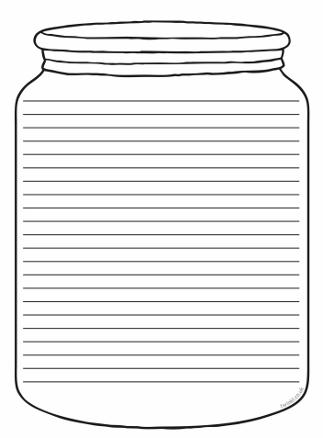
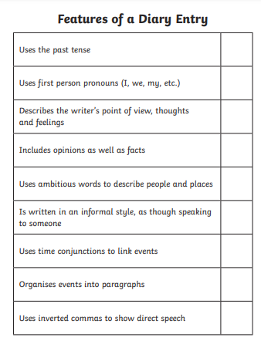

Conversion: 1 litre = 1000 ml
What type of containter?  (jar, box, cup, | Picture of container | Estimate | Actual | Conversion mm to litre
_________________ |  | ___________________ | ___________________ | ___________________
___________________ |  | ___________________ | ___________________ | ___________________
___________________ |  | ___________________ | ___________________ | ___________________

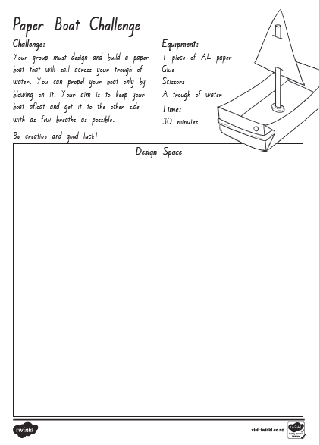
Task  What is you task?  ___________________________  ____________________________  ____________________________ | Imagine  What ideas could you use for your design?  ____________________________  ____________________________  ____________________________  ____________________________  ____________________________ | Plan  Plan your design. What will it look like?
Create  What materials did you use?  - ________________________  - _______________________  - _______________________  - _______________________  - _______________________  - _______________________ | Improve  What improvements could you make to your design?  If I made this again I would ____________________________  ____________________________  ____________________________  ____________________________ | Share  Ask a friend for constructive feedback. Record what they say?  ____________________________  ____________________________  ____________________________  ____________________________

