FOREST SCHOOL FUNDRAISING

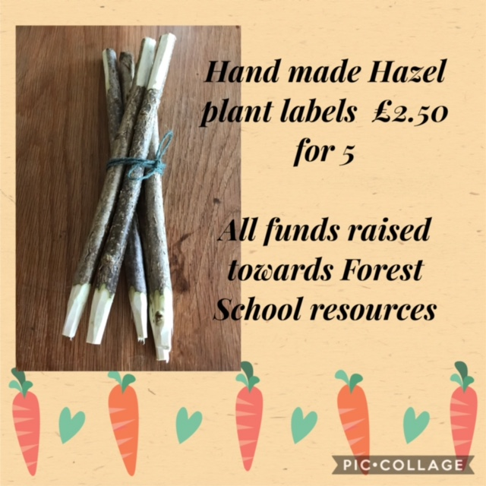

If you would like to order a set they are blank for you to add your name, they would make a lovely Mothers Day gift please email Mrs Hazel to place an order it will be cash on collection from school.
jhazel@cadmoreendschool.org

