Cadmore End
Primary School
Calculations Policy
May 2021

Year 1 - 6

Introduction and rationale
The Cadmore End calculations policy has been written in conjunction with the Hamilton trust scheme adopted by the school in 2020. https://www.hamilton-trust.org.uk/maths/
The idea of this policy is to promote consistency throughout the whole school and strengthen assessment practise in maths. This whole-school strategy will continue to strengthen pupil’s own learning and assessment results.
Having a clear and consistent curriculum strategy throughout our school enables teachers to ensure that children are hearing consistent language and using progressive methods that build from one year to the next.
Our whole school approach facilitates teacher communication about objectives, assessment and children's achievement in every year group.
Calculation Strategies
Hamilton's calculation strategies set out methods of mental and written methods for addition, subtraction, multiplication and division from Year 1 through to Year 6. Articulated for each year group, these methods ensure consistency of teacher input and progression in pupil learning. They spell out the steps that children need to take to master these four operations. By ensuring that the language is pedagogically correct, the strategy helps promote understanding in Key Stage 1, while laying the correct building blocks for understanding with greater sophistication in Key Stage 2.

This policy enables teachers and pupils to easily see how one year builds on from another. Teachers have layout models that are clear and mathematically correct so that children do not build up misconceptions through their early years that they will need to unpick later.
Addition/Subtraction Calculation Strategy
The addition/subtraction calculation strategy covers place value and its use in mental and written addition and subtraction from Year 1 through to Year 6. Counting on, counting up, number facts and compact and expanded column addition are progressively described and illustrated.
Addition and subtraction are inverse operations. Right from the start children are taught these as related operations. There are four number sentences (two using + and two using -) which can be written to express the relationship between 4 and 6 and 10. It is key to a good understanding of addition and subtraction that 6 + [] = 10 and 10 - 6 = [] are seen as ways of expressing the same question.

Multiplication/Division Calculation Strategy
The multiplication/division calculation strategy covers mental and written multiplication and from Year 1 through to Year 6. Clever counting, grouping, doubling and halving, grid multiplication and short and long written division are progressively described and illustrated.
Multiplication and division are inverse operations. Right from the start children are taught these as related operations. There are four number sentences (two using x and two using ÷ which can be written to express the relationship between 5 and 9 and 45. It is key to a good understanding of division that [] x 5 = 45 and 45 ÷ 5 = [] are seen as ways of expressing the same question.

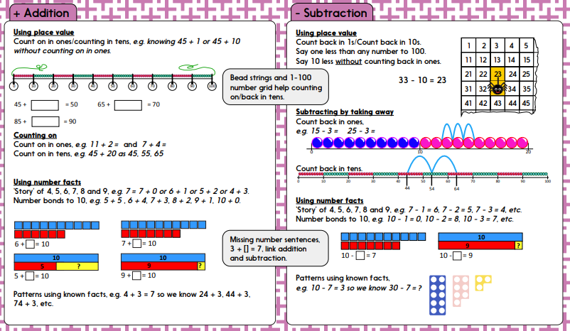
Year 1
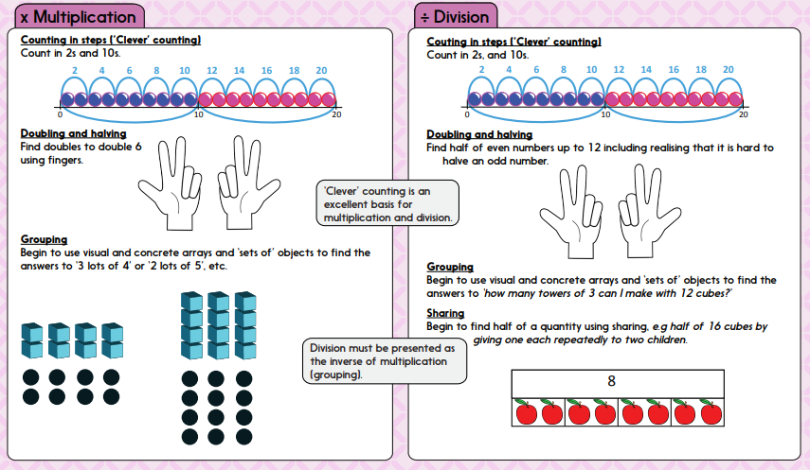
.

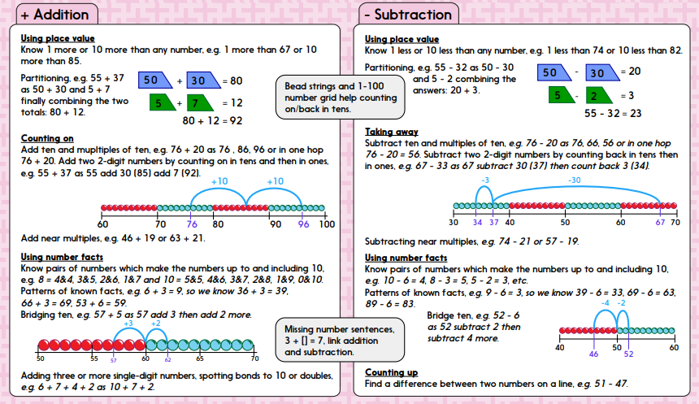
Year 2

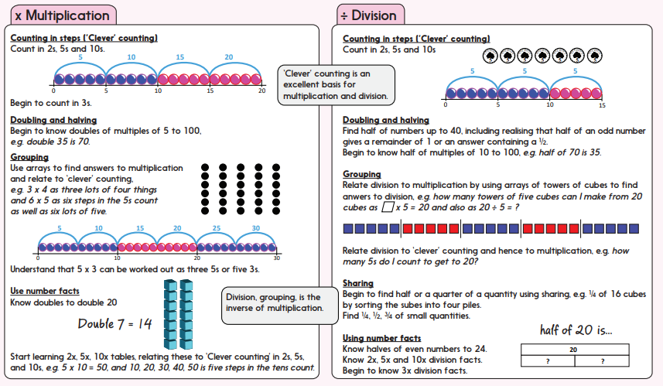
Year 3
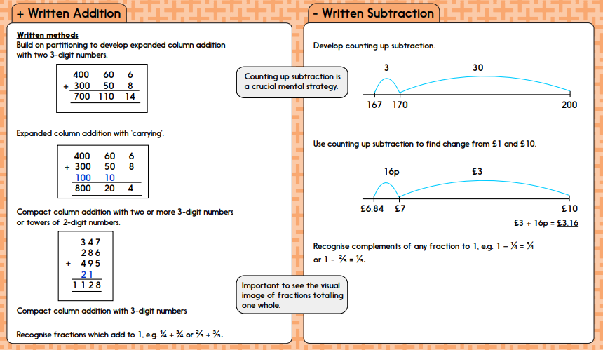
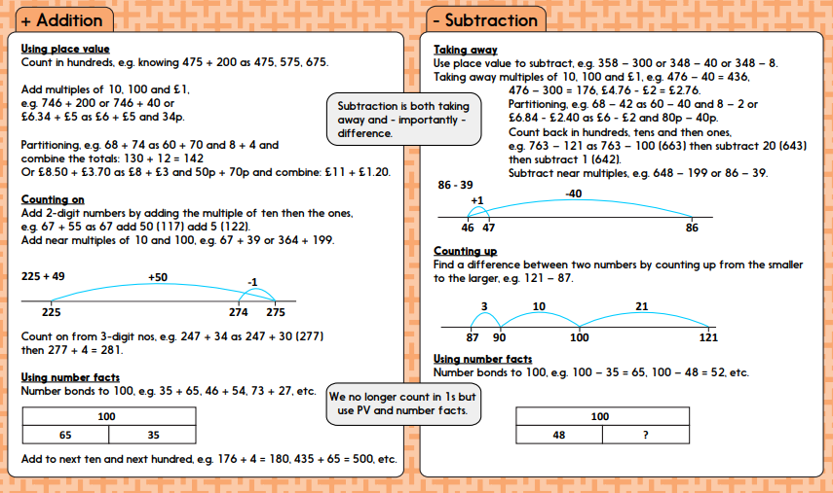

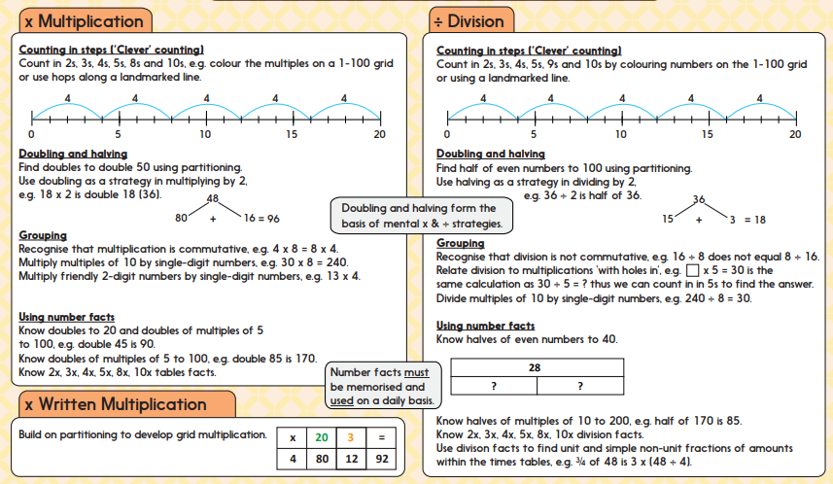
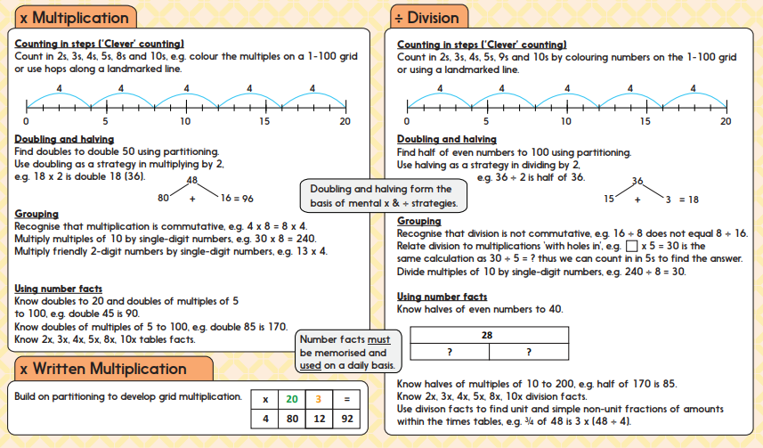

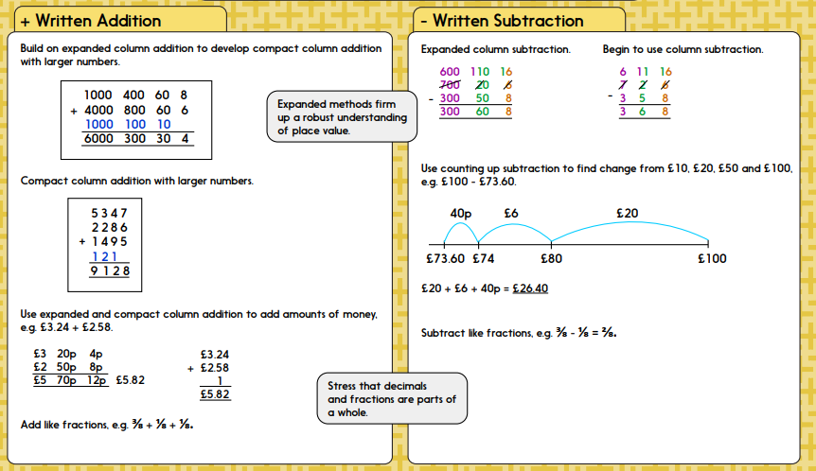
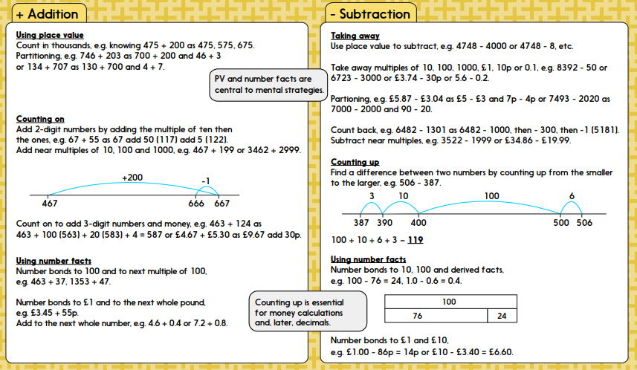
Year 4

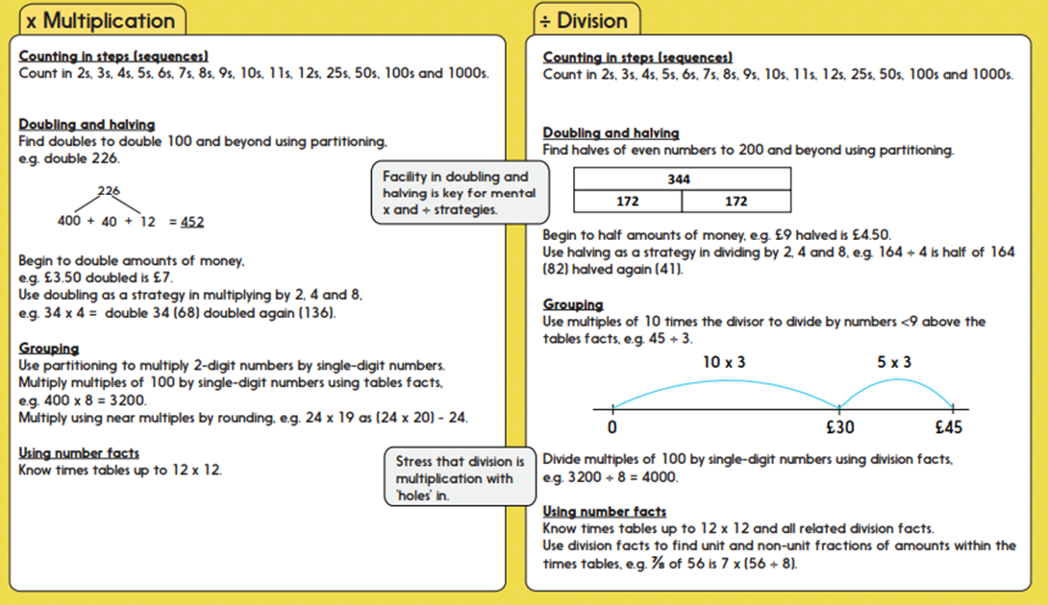

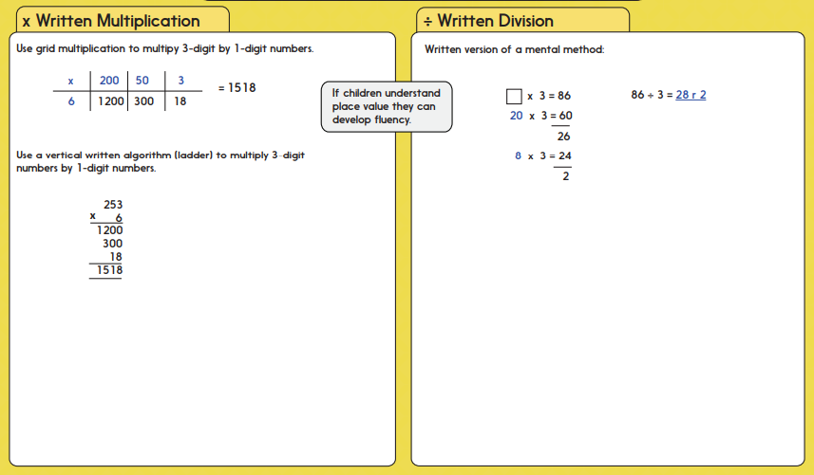
Year 5
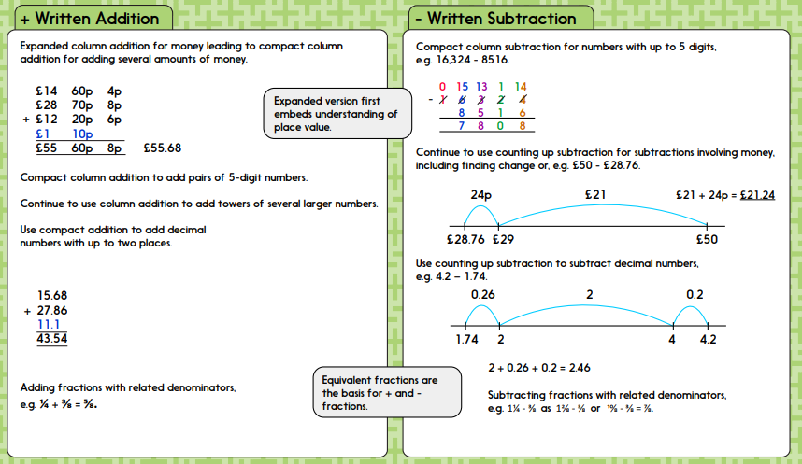
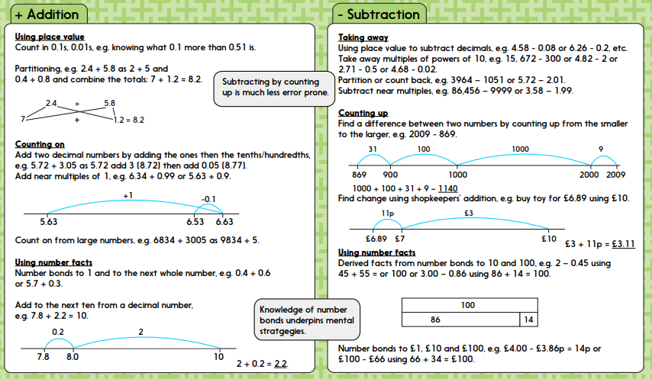
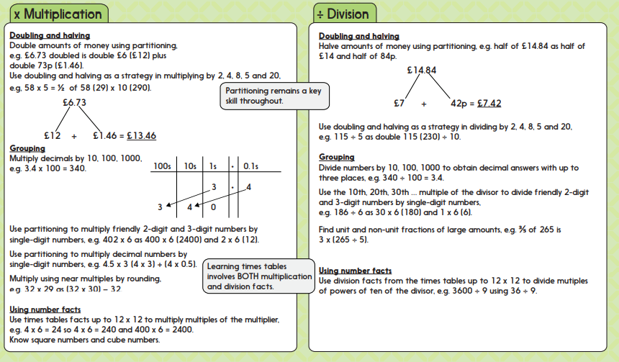

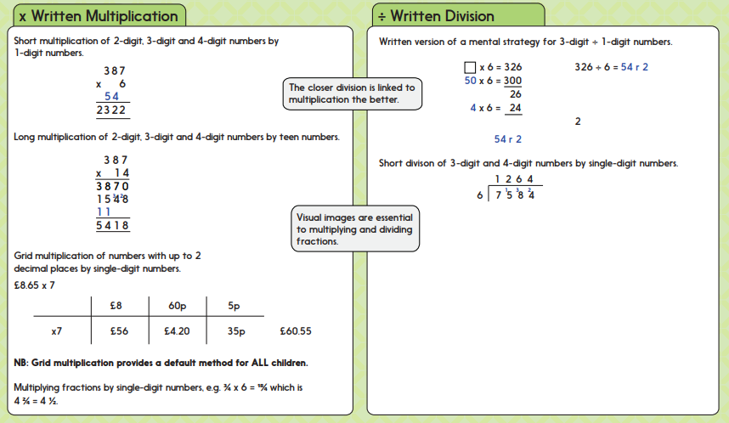

Year 6
