Early Years snow day activities
Here are a few learning activity ideas for you. Have a go at as many as you like!
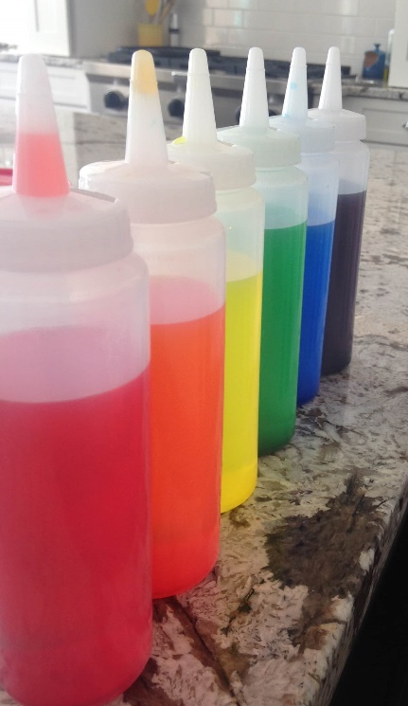Have a go at mark making in the snow.  Use water and food colouring to ‘paint’ your picture! | Build a snowman, snow child, snow animal or snow building. | 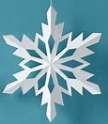Make a paper plate snowflake.  Decorate it!
Investigate snowflakes – can you find two that look the same? Can you catch one on your tongue. | Build a snow fort outside or a snuggly, warm den inside using blankets and cushions. | Go on a winter walk.  What can you hear, see, smell, feel?
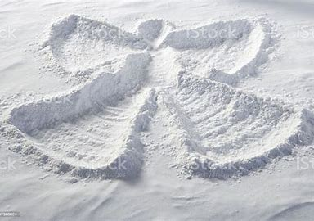Make a snow angel! | Read a wintery or snow themed story book with a grown up. | Melting challenge – collect cups of snow and attempt to either stop the snow melting or make the snow melt as fast as possible.

We would love to see pictures of what you get up to. Please could your grown-ups upload any pictures to Evidence me, or email us to the school office - office@cadmoreendschool.org
Have lots of fun in the snow!

