Class 1 weekly update

(10th- 15th October 2022)

Our learning theme this week is: Celebrating what makes us unique!
Books of the week: Elmer / My skin, your skin Poem of the week: Colours
Collective worship: Armour of God https://www.youtube.com/watch?v=QKjnjsLFgMc

Nursery

- The children are going to be listening carefully to the story of ‘Elmer’ and ‘My skin, your skin’. They will be talking about what makes each of us special.
- In forest school the children will be using a slackline and thinking about how they can use it in different ways!
- They are also going to be learning to match and name numbers to 5 this week. Can you find any numbers around your house?

Reception
- As part of Black History Month we are going to be learning about some very special people. The children will be learning about Martin Luther King, Marcus Rashford and Katherine Johnson. They will also be reflecting upon what makes each one of us unique.
- In phonics the children will be learning the sounds: h, b, f, l. They will also be learning to recognise tricky words ‘I, go no’. Why don’t you write them down and hide them around your house to find?
- In our Maths carpet time this week we will be finding one more and one less than a given number. We will be using a number line to help us!
Makaton sign of the week

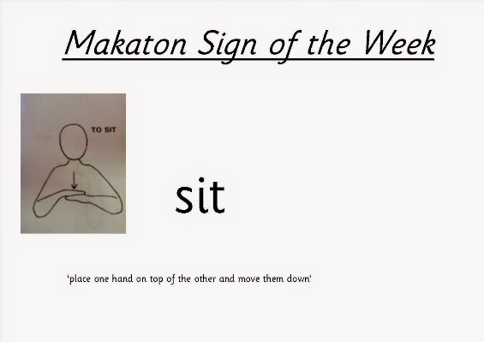
Evidence Me
It has been lovely to see more parents accessing Evidence Me and commenting on pictures that we post. The children who have pictures sent in from home also really enjoy sharing them with the rest of the class. Please keep sending them in! Look out for our phonics updates each week too so that you can support your child on their reading and writing journey.
If you’re having any technical issues or would like to know more about how to use it, please ask one of the members of staff. We are happy to help

