How to develop fine motor control

Fine motor grip |  | Practical ideas
Skills that children will need before they can write | - Body and spatial awareness | - Opportunity to play outside, to make dens, climb in and out of different size spaces, climb trees and play hide and seek
 | - Lateral and bilateral co-ordination; using two hands together effectively, one to hold pencil and the other to stabilise the page | - Opportunity to use one hand and two hands to complete tasks such as building with construction toys  - Using scissors and painting using rollers  - Large loose part play  - Climbing
 | - Visual perception, visual motor integration and form and space perception which are needed to recognize letters/ words/ and position words on paper | - Playing outside and having opportunity to strengthen the use of the eyes by looking and focusing on things at different distances.  - Play with squirt guns to hit a balloon target.  - Bats and balls/ bean bag in the bucket/ skittles  - Eye spy games in the environment and in books  - Movements to support vestibular such as spinning, sliding, rolling, up and down movements; such as see-saw and trampoline
 | - Postural stability; without this children may slump at table or keep their head close to their paper or sit on their feet | - Scooter board activities on the tummy  - Moving like different animals: slithering snake, crawling cat, moving like a lizard etc.  - Climbing
 | - Hand-eye coordination | - Puzzles, threading, weaving, wood work bench
 | - Sensory integration including how much strength require to hold the pencil to write (proprioception) | - Opportunity to lift, pull, push and carry things that cause resistance such as:  - Large loose parts  - Wheel barrows  - Rolling logs  - Climbing and hanging
 | - Attention, focus and motivation | - Opportunity to move regularly in a range of different ways  - Heavy work activities (as above)  - Games to support attention and concentration such as ‘Kims Game’ and memory games with increasing steps  - Model writing in lots of fun and engaging ways!

Fine motor grip | Development | Practical ideas
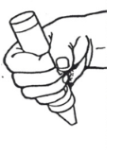  Palmer supinate grasp | Shoulder pivots:  (Movement mainly coming from the shoulder)  - Use of the whole arm; the movement is from the shoulder.  - As child’s arm movements develop, they gain more movement in their elbow pivot and the shoulder moves less. | Continue with ideas above as appropriate.  Shoulder pivot:  - Use paint rollers on a wall, moving up and down and side to side  - Crawling through tunnels  - Flying a kite  - Sweeping or cleaning with brooms/mops  - Digging with long handled spades  - Climbing and pulling up on climbing frame  - Lifting large wooden blocks  - Pull along toys  - Steering ride on bikes and vehicles
Digital pronate grasp  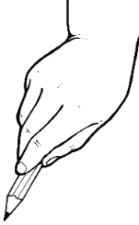 | Elbow pivots:  (Movement mainly coming from the shoulder and elbow)  - Elbow bends allowing for larger range of movements but shoulder still drives movement of the arm back and forwards.  - As the elbow pivot develops, the child can use their muscles in the upper and lower arms to swing in and out from their body in a semi-circle action  - To fully develop elbow pivot children need to complete push/ pull circular movements- like mixing cake mixture or winding a hand whisk | Shoulder pivot: Children may still require the physical skills above. Look to see how children are using their arms during play and mark making.  Ideas to support elbow pivot:  - Using handled winding whisk  - Washing wall or large vehicles with sponges  - Under arm rolling/ throwing ball  - Weaving with ribbons  - Human wheel barrow racing  - Large loose parts  - Monkey bars  - Scooping  - Short handled spades, sand, soil and buckets  - Stirring with large spoon, whisk or spatula – challenge with very sticky mixtures  - Making play dough – kneading the dough

Static tripod grip/ expanded grip  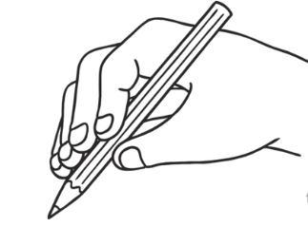 | Elbow and wrist pivot:  (Movement driven mainly from the wrist)  - Mostly children’s elbows will be off the table, movement takes place from elbow and wrist generally.  - It is important at this stage to try and support children to amend their grip to the triangulation grip.  - If a child begins to write recognisable letters with this grip or any other unusual grip they will get into bad habits. The more they do it the more they embed the grip. | Shoulder and elbow pivot:  - Children may still require the physical skills above. Look to see how children are using their arms during play and mark making.  Wrist Pivot:  - Pouring with jugs, bottles, scoops and spoons  - Keys and padlocks  - Jars with twist lids  - Threading/ weaving  - Puzzles/ shape sorters  - Cutting fruits with a knife  - Hand puppets  - Cats cradle games  - Bottles with twist lids  - Dab painting  - Splatter painting  - Climbing up rope/ climbing frames  - Human wheel barrow racing
Unusual grips:  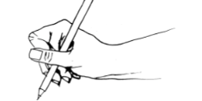  Inverted tripod grip | Unusual grips:  - Unusual pencil grips such as inverted tripod grip usually develop because children have not formed enough dexterity in their final finger joints. | Dexterity in final finger joints:  - See ideas below

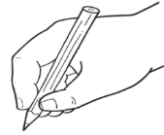  Triangulation grip | Fine motor control:  - To get to this grip children will need to strengthen the many muscles within their hands and fingers.  - Mark making implements are controlled by the pivoting joints for the thumb and fingers from the first 3 fingers. This allows for maximum flexibility and maximum range of movement and this is why it’s the ultimate grip.  Skills to support development:  - Pincer grip  - Hand-eye co-ordination  - Finger isolation  - Knuckle, PIP and DIP joints  - In-hand manipulation  - Thumb opposition 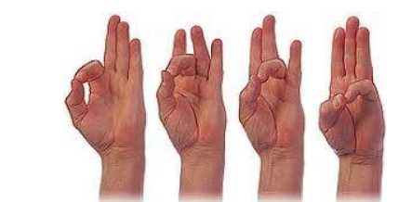  - Palm arches | Pincer grip:  - Fiddley small part resources eg – nuts, bolts, conkers, lollipop sticks, milk bottle tops, fir cones, pieces of ribbon, corks etc.  - Playing with rice, sequins, small collage parts eg – Transient Art  - Pegs/ tongs to move or place items  - Using fingers to fill small containers or bottles with small beads or pasta  Hand eye coordination and pincer grip:  - Puzzles and threading  - Loom bands, finger knitting and sewing  - Construction toys eg – Lego, Mobilo, K-Nex  - Screws and bolts, hammer and nails  Finger isolation:  - Finger puppets  - Gloves in role play or to make puppets  - Access to pianos, keyboards or recorders  - Counting using fingers  - Makaton  Knuckle, PIP and DIP joints:  - Using play dough, clay, Plasticine and cutters and tools  - Construction toys eg – Lego, Mobilo, K-Nex  In-hand manipulation:  - Small construction toys, real tools with nails and screws  - Pennies in piggy bank, opening purses using one hand  - Manipulation of objects using one hand such as moving objects around in the palm of the hand.  - Jacks game, handling dice  - Moving or twirling a pencil or crayon up and down or in between fingers using just one hand  Thumb opposition:  - Thumb opposition/ thumb opposition starting from different fingers  - Progress to completing thumb opposition in opposite directions on each hand  Palm arches:  - Squeezing sponges eg – cleaning ride-ons  - Wringing out water when washing dolls clothes  - Playdough and corn flour  - Squeezey bottles and water pistols  - Squeeze balls, sensory toys, balloons filled with water/sand or other sensory materials  - Unscrewing jars

