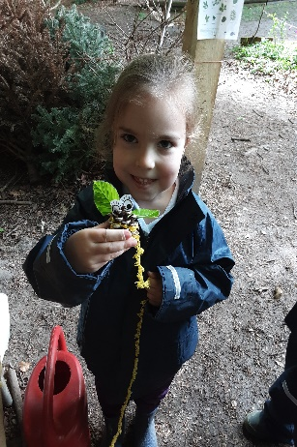
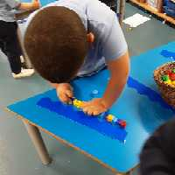
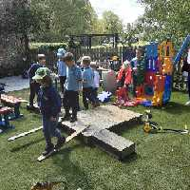
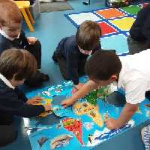
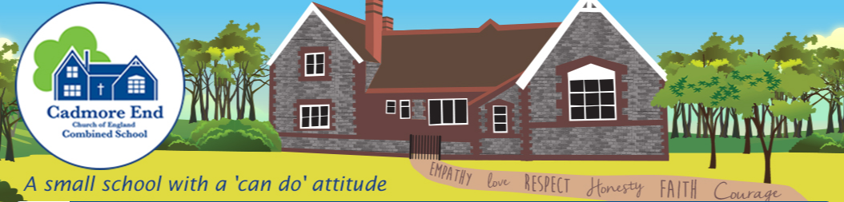
Welcome to Reception

September
2021
A small school with a ‘can do’ approach.
From small beginnings come great things- Matthew 13:31-32

Meet the Reception teachers…

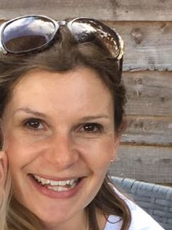
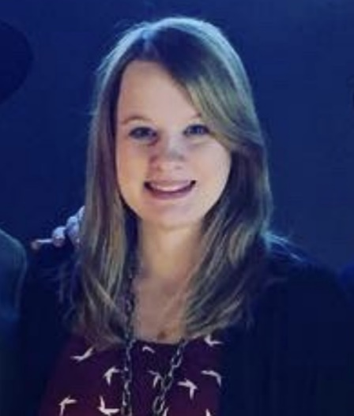

Mrs Croft Mrs Dawkins
Class Teacher Class Teacher
Monday – Wednesday Thursday – Friday

A small school with a ‘can do’ approach.
From small beginnings come great things- Matthew 13:31-32

Meet our support staff…

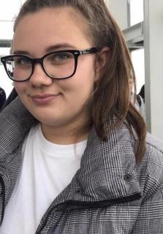
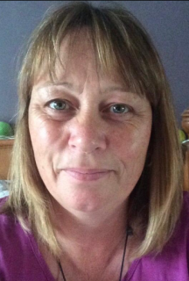

Mrs Hazell Miss Hazell
Nursery Practitioner and Nursery Practitioner
Forest School Leader afternoons
A small school with a ‘can do’ approach.
From small beginnings come great things- Matthew 13:31-32

The recipe to a successful transition…
- Have trust and work in partnership with us.
- During the first half term, Reception staff will support the children and model the correct eating habits, routines and behaviour expectations.
- Look carefully at the uniform requirements for school, PE and forest school. (in your packs)
- Fill in and send back paperwork ASAP.

A small school with a ‘can do’ approach.
From small beginnings come great things- Matthew 13:31-32

What will my child need?

Uniform
- Please see the school uniform link on our website
- Forest School kit- again please see the link on the letter for more details. We will let you know the timetabled forest school day in September.

Spare Clothes
- Children will need a draw string bag with spare clothes to be kept in school in the event of an accident. This should include PE kit and several pairs of underwear!
Wellies
- Children will need a pair of named wellies to be kept at school for Forest School and outdoor learning.

Named Book bag
- These are great for the very little children need to bring into school and can be stored easily.
- Please ensure the book bag is clearly named- embroidery patches are great!
- No water to be carried in the book bags please!

Water Bottle
- Water only please
- Clearly named
- Your child must be able to open and close the lid

Additional Snack
- Some parents choose to send their child to school with a fruit of their choice.
- Fruit is supplied to children in school from Reception to Year 2. It may include- bananas, tangerines, tomatoes, apples, pears, carrots
- An afternoon cracker/rice cake snack or additional fruit snack can be useful for those children who run out of energy!
- Remember, we are a nut free school and all snacks should be healthy.

A small school with a ‘can do’ approach.
From small beginnings come great things- Matthew 13:31-32

How we communicate with you

- Daily communication at start/end of day.

- The reading record- more information on reading and phonics to come!

- Pupil progress meetings.

- Evidence Me – a tool we use to record and assess children’s development.

- General reminders of upcoming events via the school website and weekly newsletter

- Termly Class newsletter outlining the curriculum topics we will be focusing on.

A small school with a ‘can do’ approach.
From small beginnings come great things- Matthew 13:31-32
Settling in days….
Thursday 2nd September- Individual meetings with the class teachers and a chance to explore the environment and ask any further questions.
Friday 3rd September- Settling in morning 9.15- 1.15pm for the children only. Packed or hot lunch available to order. (see lunch form in your pack)

A small school with a ‘can do’ approach.
From small beginnings come great things- Matthew 13:31-32
The School Day- practical information
Start of term- Monday 6th September 2021
Arrival
Children to arrive at the Early Years Gate for an 8.50 start. A member of the team will meet you upon your arrival. Adults are not permitted in the building, so please say your goodbyes in the garden or on the ramp.

Departure
The gate will be opened at 3pm for you to collect your child at 3.05pm from the Early Years Department. Key messages will be relayed to you. If you need to speak to the class teacher, please wait until all children have been dismissed safely.

A small school with a ‘can do’ approach.
From small beginnings come great things- Matthew 13:31-32
How to help your child to prepare…
- Our topic for the Autumn Term will be ‘All about me’. We will be settling children in, getting to know them and build relationships with them.

- Talk to your children about starting school and getting them ready. Be positive about this new chapter of starting school!

- Look at the pictures of our learning environment from the school website and make a little ‘mini me’ (Photo of your child on a string or spoon) and take the ‘mini me’ on a journey through their classroom pictures. Ask them to think about what they might do/play with.

- Watch the videos of our virtual tour and stories via the school website so your child can see and hear our voices before they start.

- Look out for some important post, addressed to your child! It will contain an ‘Everywhere Bear’ Puppet and a letter to explain what we would like you to do! Take the puppet with you on day trips during the summer have and bring a picture or drawing to school on your first day to share with the class.

- Send or email the office some important pictures of your child’s family and favourite toys. – We will be displaying these in the classroom so they can see photos of familiar family members, pets and toys.

- Travel (walk or travel by car) to the school and look at it from the outside so the children can see where they will be going.

- Over the holidays play with numbers the children see all around them - house numbers, car numbers, bus numbers, etc. Help them to count accurately by getting them to help you when laying the table e.g. correct numbers of knives, forks, spoons or sharing out sweets, grapes etc. so that everyone has the same amount.

- Take your children to explore the things around them and be curious.

- Read with your child and discuss stories with them over the summer. Encourage them to talk about the story. For example, what can they tell you about the story? What do they think is going to happen at the end? What did they enjoy about the story? Can they make up their own story?

- Encourage your child to be as independent as they can be with self- help skills such as toileting, washing hands, putting shoes on the correct feet, putting their coat on etc.

- Take the time to fill in the enrolment forms and send them back as soon as possible to help us plan for your child’s individual needs.

A small school with a ‘can do’ approach.
From small beginnings come great things- Matthew 13:31-32

What do the children do in The Early Years Foundation Stage (EYFS)?
There are 7 areas of learning
3 Prime areas-
- Communication and Language
- Personal, social and Emotional Development
- Physical Development

4 Specific Areas:
- Literacy
- Maths
- Understanding of the world
- Expressive arts and design
Our carefully tailored curriculum is centred on child development to encourage language acquisition, confidence and awe and wonder in the world around us.

What does a typical day look like in EYFS?
8.50- Arrive and settle to a fine motor activity
9.15- Carpet time with the register, date and language focus.
9.40- Phonics
10am – Play to learn- inside or outside
10.45- Snack time – milk and fruit are provided
11. 30- Maths
12.00 -1pm- Lunch
1-00 Register and story
1.30 – Play to learn inside or outside
2.30- Snack
2.45- Yoga/Singing/story- Home!

Any questions?

A small school with a ‘can do’ approach.
From small beginnings come great things- Matthew 13:31-32

Thank you and a huge welcome to Cadmore End Church of England Combined School

We hope you have a wonderful summer holiday and look forward to seeing you in September on your initial school visit where we can discuss any concerns or queries you may have regarding your child’s start to Reception.

