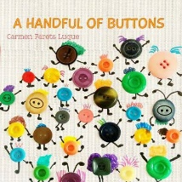
Class 1 weekly update

(19th- 23rd September 2022)
Our learning theme this week is: Our Family
Book of the week: A Handful of Buttons by Carmen Parets Luque Poem of the week: All About Me
Breathing Technique this week: ‘Snake Breath’ https://www.youtube.com/watch?v=bjhozwhJ8J8 You may wish to try this at home.
Collective worship: Our Bible story this week is all about ‘God the maker’, Psalm104. We will also be learning some new songs with actions about the creation story.
Date for your diary!
Friday 30th September- We will be performing a short song during Celebration Assembly for Harvest as we will not be going to the church in the afternoon. You are welcome to attend. We can film this on Evidence Me for those unable to be there.
Nursery
- As part of our phonics we will be making sound shakers.
- In maths we will be learning some counting actions.
- We are going to have fun moving like animals!
Reception
- Our phonics adventure continues with consolidation of last weeks’ sounds- ‘s,a,t,p’ and learning these new ones too- i,n,m,d. Each lesson involves blending sounds together to read simple words such as ‘tap, pan’ etc. Can you think of an object beginning with these sounds?
- In our Maths carpet time this week, we will learning about symmetry.
Makaton signs of the week

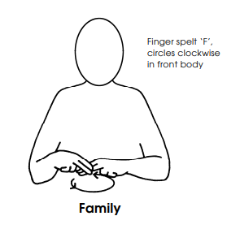

A few reminders
Phonic workshop for Parents.
This Thursday 22nd, 9am start in the hall.
Book bags and water bottles
Please help your child to put their water bottle and book bag (with their reading record and book inside) into our boxes by the door when they arrive in the morning.
Reading Books
Books are given out on a Tuesday and Friday.
Library books
Nursery- Friday - Friday
Reception- Monday- Monday

- We will be making our own button families to help us talk about how special our families are.

