Cadmore News
Friday 10th July 2020

Dear parents and carers,
The summer term is nearly over. What an academic year this has been!
As this is my last newsletter for this academic year, I would like to say a huge thank you to all the staff for embracing how we teach our children. I am very pleased with the level of communication teachers have had with all of our families. I do hope you agree.
We also want to say a huge thank you to our families for ensuring their child or children continued with their learning at home. As a parent myself, it is not easy especially if you have a large family or you work.
I am confident that we will be able to meet the Government recommendations and open fully to all children in September and provide wrap around care. I will send a letter out with information about how the school will operate the week before children return
School reports
On Monday, you will receive your child’s school report. Due to these unprecedented times, the report is a snapshot of your child up until school closed on Friday 20th March 2020.
For children in classes 2-4, their report card is also attached. This gives you details of their attainment levels as of February 2020. For children in Class 1, their Profile is attached. This gives details of their achievements up until March 2020.
Leadership opportunities for our children
We will have several opportunities for children to become leaders for our school. We have our school council, Head Girl and Head Boy and our House Captains.
We will be introducing Forest Rangers. These children will work alongside Mrs Hazell in developing our woodlands and garden area.
If your child would like to become a leader, please follow the instructions below. The spaces are as follows
Leadership opportunity |  | How to apply
School council | No spaces. Children who were part of the school council for the academic year 2019-2020 will continue as they did not have an opportunity to enjoy their role. | N/A
Forest ranger | 1 per class. Available to children in (as of September 2020) Classes 2, 3 and 4 | Write a short piece about why you think you would be a good Forest Ranger. What ideas do you have?  Please send your application to Mrs Hazell jhazell@cadmoreendschool.org
House captain | Available to children in (as of September 2020) Class 4 | Write a short piece about why you think you would be a good House Captain. What ideas do you have to make collecting house points fun?  Please send your application to Mrs Whayman-Bailey dwhayman-bailey@cadmoreendschool.org
Head Girl and Head Boy | Available to children in (as of September 2020) Class 4 | Do you uphold our school values? Would you like to be involved in meeting visitors and showing them around our school? If the answer is yes please write a supporting statement. Why should you be chosen?  Please send your statement to Mrs groom head@cadmoreendschool.org

Childcare
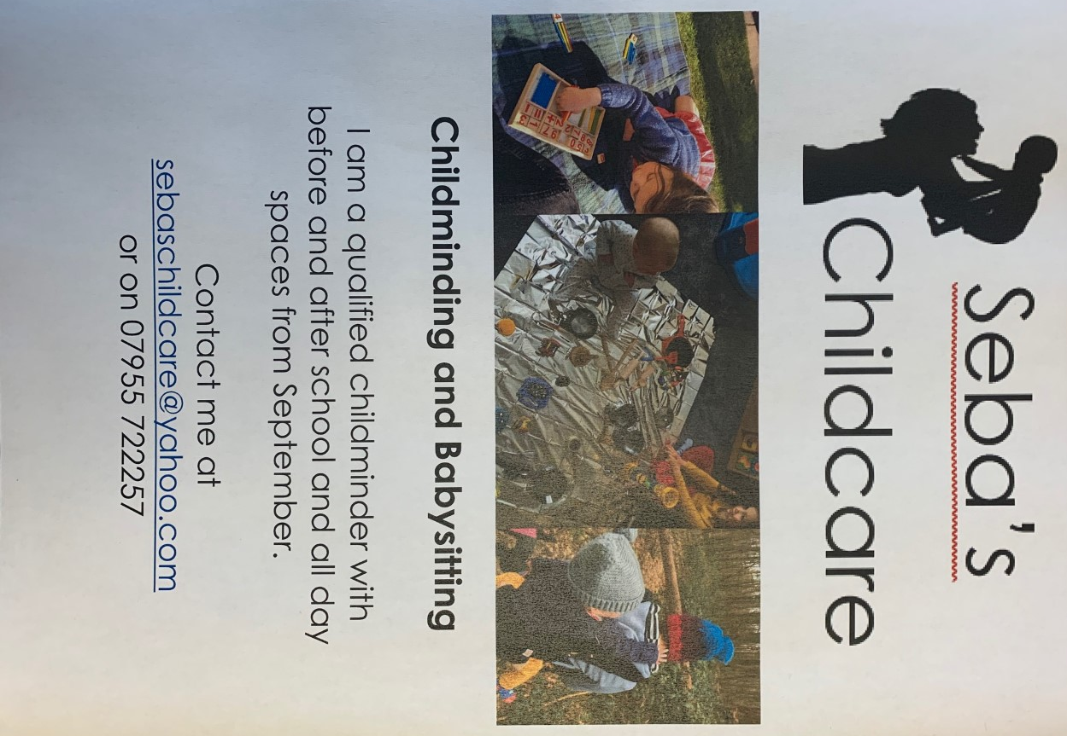
We will continue to provide wrap around care, however, Seba Smiley (Olivia’s mummy) has started up a childcare business. Here are her details if you are interested.
Year 6 Leavers
We will be holding a special assembly for our Year 6 children on Friday 17th July at 1pm. Unfortunately this is only open to Year 6 children and their family only.
If your child is in Year 6 and you have not yet responded to the invitation, please can you do so ASAP.
Last Day
Nursery children’s last day will be Wednesday 15th July. The rest of the school will finish on Friday 17th Jully.

Wishing you all a safe and restful summer holiday.
Mrs Groom
Headteacher

