**Maths:**

As a suggestion Year 3 and 4 should aim to do a minimum 45-60 minutes of maths a day. This includes Mathletics, purple mash and extra activities suggested in this document.

Summer term 1 is all consolidation of maths skills and functions. Each week or so I will set tasks and activities that focus on one maths calculations, such as addition, subtraction, multiplication or division.

The activities on Purple Mash and **Mathletics** will continue to be a consolidation of maths already taught.

This Weeks Activities are all based on **subtraction**. In Class 3, we know written methods for addition. Number line and Column subtraction. Along with this document are some powerpoints to help support children with these methods, however, as these have already been covered it should just act as a reminder. The following activities can be completed using either method, although it is suggested that children chose whichever method suits them and the problem. I would ask that children practice using the column method, as this is the formal written method they are required to learn.

1. [Topmarks](https://www.topmarks.co.uk/Search.aspx?Subject=16&AgeGroup=3) have wide range of games to engage children in maths. The link below is for a mental maths game. It will ask you to choose one or two numbers to work with, there will be missing numbers, to score points you must put the correct number in the number sentence to make the subtraction complete. <https://www.topmarks.co.uk/maths-games/subtraction-grids>
2. Using counters or dice, create subtraction. Roll the dice to create 2,3 or 4 digit numbers and take them away. Remember that addition can be done in any way, but in subtraction, we must always put the biggest number at the top.
3. Have a go at the subtraction board game. Take turns with your family members. Use a whiteboard or paper to make notes using the column method to solve each problem.
4. There are word problems on this document, rated by chilli challenge. You may wish to stick with one level or work your way through each challenge.
5. Magic Square Challenge, read the instructions and have a go at this puzzle.

Daily Maths activities,

* Timestables:
* Year 3 should focus on recall and use multiplication and division facts for the 3, 4 and 8 multiplication tables. However please ensure that children are confident with 2s, 5’s and 10’s before moving on. Use Topmarks for some timestable games such as hit the button, and daily 10.
* Year 4 should recall multiplication and division facts for multiplication tables up to 12 × 12

**Use Topmarks for some timestable games such as hit the button, and daily 10.**

|  |  |  |
| --- | --- | --- |
| H | T | O |
|  |  |  |
|  |  |  |
|  |  |  |
|  |  |  |
|  |  |  |
|  |  |  |

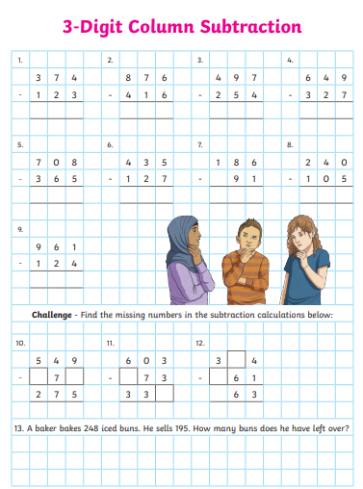

|  |  |  |  |  |
| --- | --- | --- | --- | --- |
| C:\Users\Alice\AppData\Local\Microsoft\Windows\Temporary Internet Files\Content.IE5\QRFME77E\MC900432552[1].png | 345 - 222 | Move forward one place! | 137 - 123 | 689 - 368 |
|  | | | | 468 - 354 |
| 642 - 330 | 764 - 241 | 628 - 417 | 985 - 743 | Miss a turn! |
| 628 - 417 |  | | | |
| Go back three places! | 980 - 320 | Move forward two places! | 888 – 444 | 1000 - 500 |
|  | | | | 574 - 131 |
| C:\Users\Alice\AppData\Local\Microsoft\Windows\Temporary Internet Files\Content.IE5\2WKZ0RM1\MC900056981[1].wmf | 439 - 226 | 756 - 235 | 656 – 253 | Move forward two places! |



* 1. A farmer has 584 cows. He takes 246 to anew field. How many are left behind?
  2. A school has a target of raising £275 for a local charity. SO far they have raised £149. How much more is there left to raise to reach the target?
  3. A teacher counts all the exercise books that her class has used during the year and finds there are 237 in total. 96 are Maths books. How many other books are there?
  4. A school prints 238 letters for parents. 153 are given out on Thursday and the rest of Friday. How many letters are given out on Friday?
  5. Edward buys a drink and a packet of crisps for £1.45. He pays with a £2 coin. What change does he receive?
  6. A flower market has 432 tulips. A florist buys 155 tulips. How many are left?



1. A shop has 376 pairs of socks. 87 are white sports socks and 123 are white trainer socks. How many other pairs are there?
2. There are 289 children in a school. 154 are in Key Stage 2 and 76 are in Key Stage 1. The rest are in Foundation Stage. How many children are in Foundation Stage?
3. Edward buys a drink for 67p and 2 packets of crisps for £1.18. He pays with a £2 coin. What change foes he receive?
4. A sweet shop has 591 boiled sweets in jars. One jar containing 164 and another containing 153 are sold. How many are left?
5. A farmer has 609 cows. He takes 246 to a new field and 176 to a shed. How many are left behind?
6. A school prints 482 letters for parents. 159 are given out on Wednesday, 178 on Thursday and the rest on Friday. How many letters are given out on Friday?



1. A shop has 76 pairs of socks. 33 pairs are white sports socks. How many other pairs are there?
2. There are 189 children in a school. 114 are in Key Stage 2, the rest are in Foundation stage and Key Stage 1. How many children are in the Foundation stage and Key Stage 1 altogehter?
3. There are 1145 pencils in the cupboard. 82 are given out to the children. How many are left in the cupboard.
4. Edward buys a drink for 82p. He pays with a £1 coin. What change does he receive?
5. A flower market has 132 tulips. A florist buys 80 tulips. How many are left?
6. A sweet shop has 127 boiled sweets in a jar. One jar containing 64 sweets is sold. How many are left?

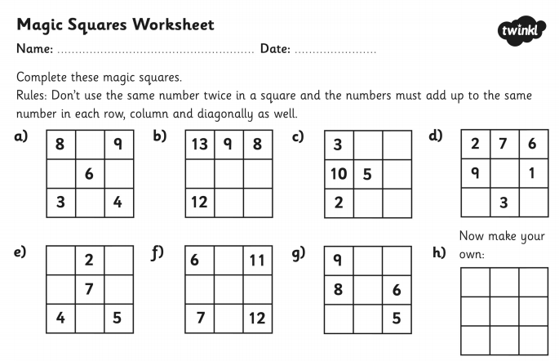

**English:** As a suggestions Year 3 and 4 should complete a minimum of 45-60 minutes of English based tasks a day. This includes the grammar and comprehension booklets, Purple Mash tasks, daily reading and spelling as well as suggested activities on this document.

This half and final term includes some poetry topics, this is something we have not covered much in school. However, I would like you to have a go with the following challenge:

Dairy Entry – I would like you to write a diary entry on one of the days in lockdown. Try and choose a day where you did something exciting. Maybe you went outside to the park and played in the grounds. Maybe you tried something new for the first time? Maybe you baked a new recipe with your family.

* Use the checklist to help you and the fronted adverbial word mat to help give your sentences variety. Remember to use a comma after the fronted adverbial.
* Try and be as descriptive as possible, because we weren’t there you need to describe the things you saw, heard, smelt, tasted, touched in as much detail as possible so that the reader gets a sense of what it was like to be there.
* Describe your feelings. How did the events make you feel and why? Try and avoid words such as sad and happy. Use more adventurous vocabulary such as excited, apprehensive, nervous, and joyful.

This week I would really like you to focus on your reading comprehension.

1. If you have not done already, try and continue or start the tasks in your comprehension booklets from the school.
2. In this document there is a poem by William Blake. Read the poem carefully. Think carefully about the poem. Talk about it with your family. What do you like about it? What don’t you like about it? Why? Then have a go at answering the questions on the next page.
3. I have set a reading comprehension activity on Purple Mash. It is the beginning chapter of a story called ‘The Sleeping Volcano’. Read the chapter, there is a quiz on Purple Mash and then on this document there are some activities for you to have a go at. Make sure you read the text carefully.
4. Sign up for the summer reading challenge! Get rewards, play games and earn badges as you discover awesome books to read this summer!

<https://summerreadingchallenge.org.uk/>

**Daily English tasks:**

1. Daily reading. Please continue to read at home. You may wish to read to a parent or sibling, read on your own or have someone read to you. Keep an eye on google classroom for story videos from myself.
2. Spellings – I will continue to set weekly spellings. However children should be able to spell High frequency words. These can be found on the following page. If your child is struggling with any of these words, I encourage you to focus on these.

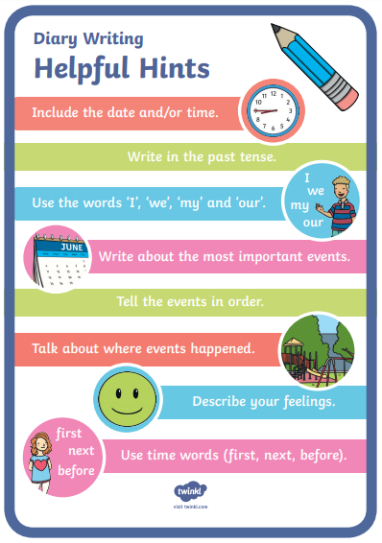

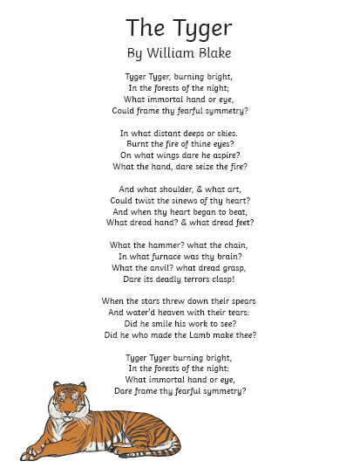

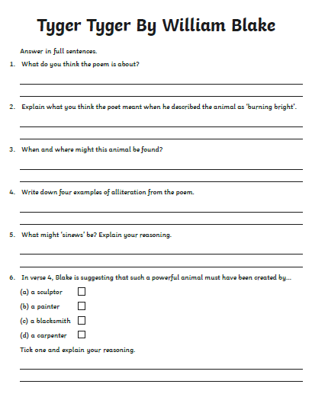

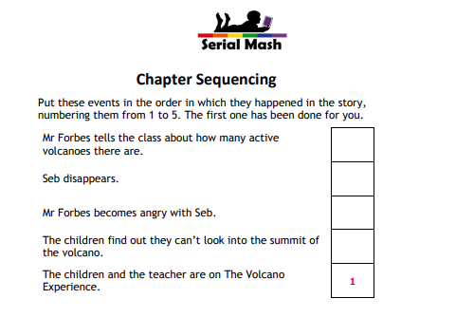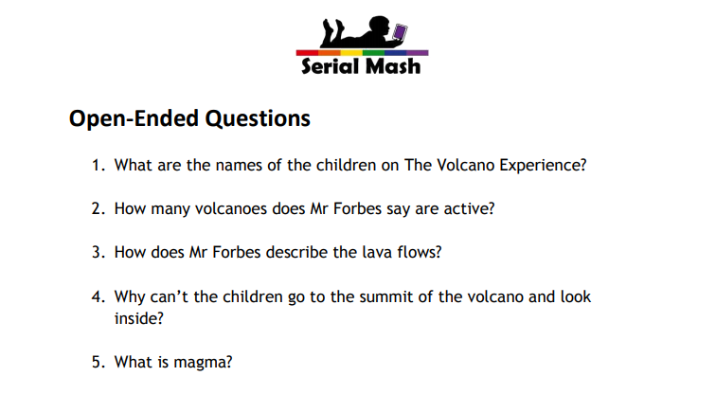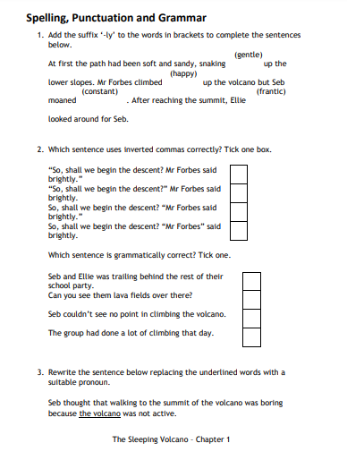

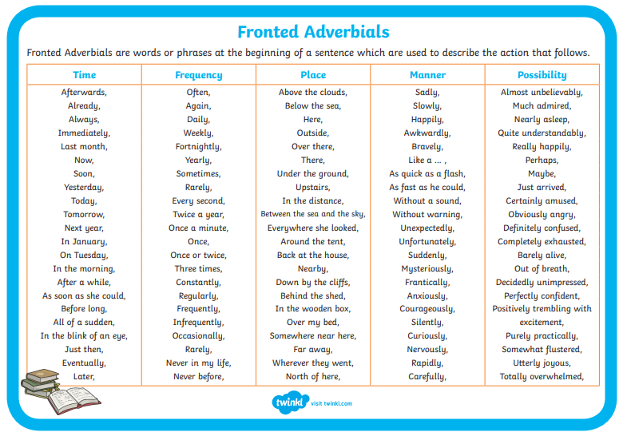

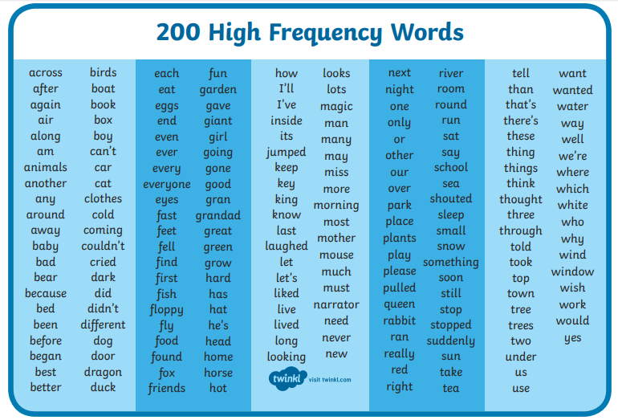

**Topic:**

As a suggestion Year 3 and 4 should complete a minimum of 45- 60 minutes of a creative task such as the topic and science tasks on this document. This can also include sports, outside learning, cooking or baking.

Our topic for the summer term is Mountains and Volcanoes. Here are a few extra ideas for practical things you may wish to do.

**Mountains:**

1. Can you create a mountain using everyday objects? How tall can you make it without toppling over?

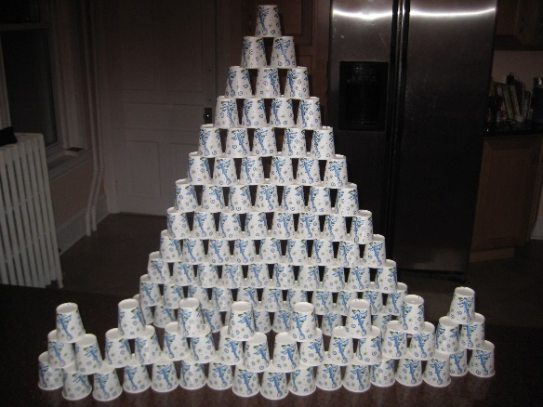

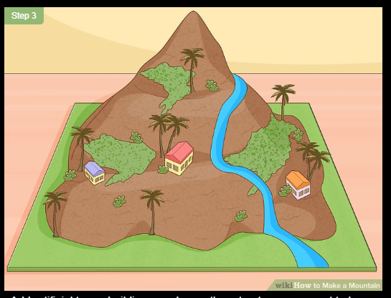

1. Create a papier-mâché mountain. Follow the link for a step by step guide on how to make one. Decorate it to look like one of the well-known mountains; Everest, Kilimanjaro, Mount Fuji, Ben Nevis or Snowdon.

<https://www.wikihow.com/Make-a-Mountain>

**Science:**

Our topic this summer term is all about sound. I will set some science activities on purple mash. Here are some other activities for you to try in addition.

1. Have a go at these activities on BBC Bitesize: <https://www.bbc.co.uk/bitesize/topics/zgffr82>
2. Draw to music. Pick a piece of music that you like to listen to. Listen carefully to the sounds, the pitch (lows and highs) what do you picture? Use any materials you like, pencil, crayons, or paint. Create a picture from listening to the music. Here are some classical pieces that you might like to try.

* <https://www.youtube.com/watch?v=aYAJopwEYv8>
* <https://www.youtube.com/watch?v=GRxofEmo3HA>
* <https://www.youtube.com/watch?v=fadmt69BBqU&list=OLAK5uy_kGWc7Hh6ZHfEqDwDTaxJq9X5fayNk2gZ0>
* <https://www.youtube.com/watch?v=5vZGzuAkWAs&list=OLAK5uy_kGWc7Hh6ZHfEqDwDTaxJq9X5fayNk2gZ0&index=20>

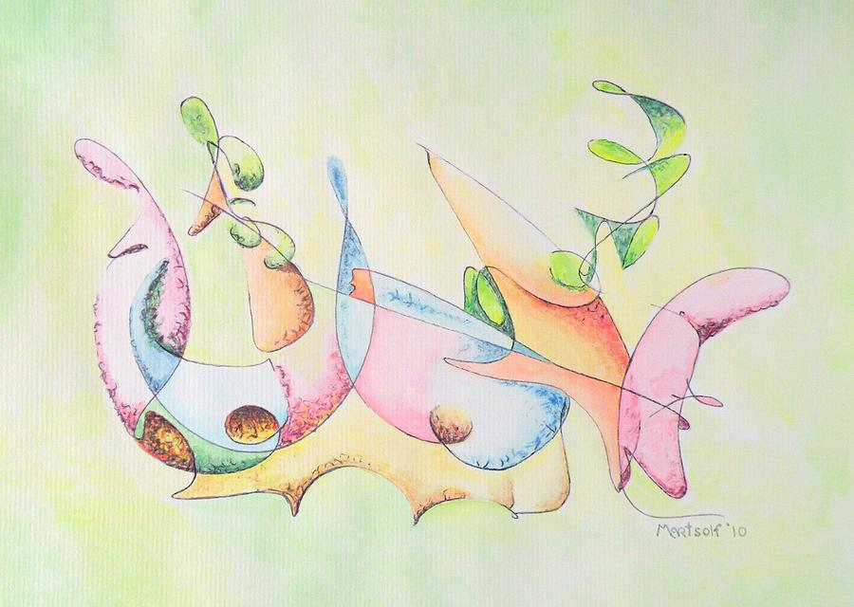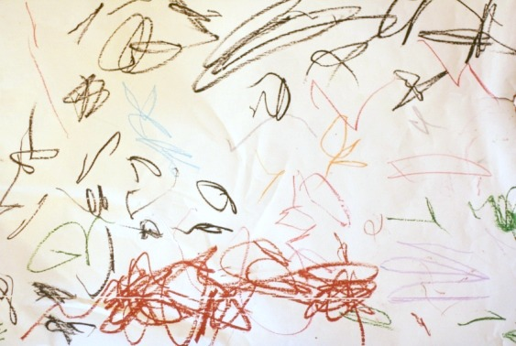

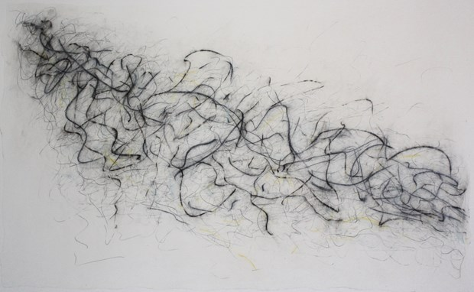

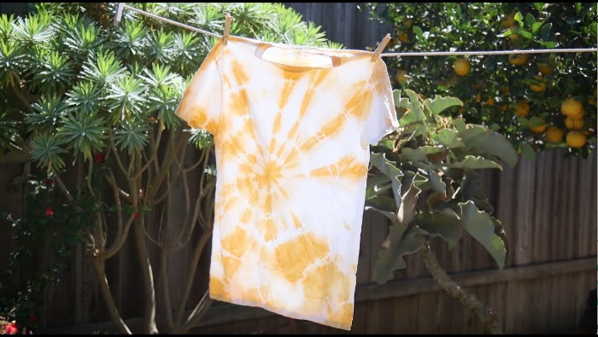**Extra activities:**

1. Easy tie dye: Have some old t-shirts or trousers lying around? Why not give them a fresh look and try out some tie dye.

<https://www.wikihow.com/Tie-Dye-a-Shirt-the-Quick-and-Easy-Way>

You may also want to try a more natural method: Try using turmeric - <https://pinkfortitude.com/tie-dye-with-turmeric/>



1. Try making some homemade pancakes, using only a few basic ingredients. Super easy to make and really tasty.

<https://www.bbcgoodfood.com/recipes/three-minute-blender-banana-pancakes>

1. Make a Mud Hedgehog.

Get out into nature, use natural materials to create a real life model of a hedgehog.

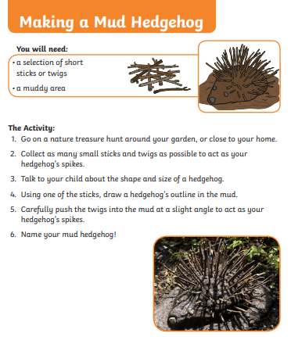

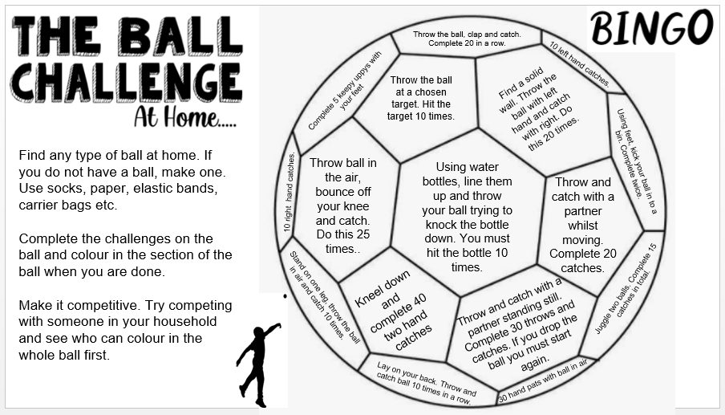

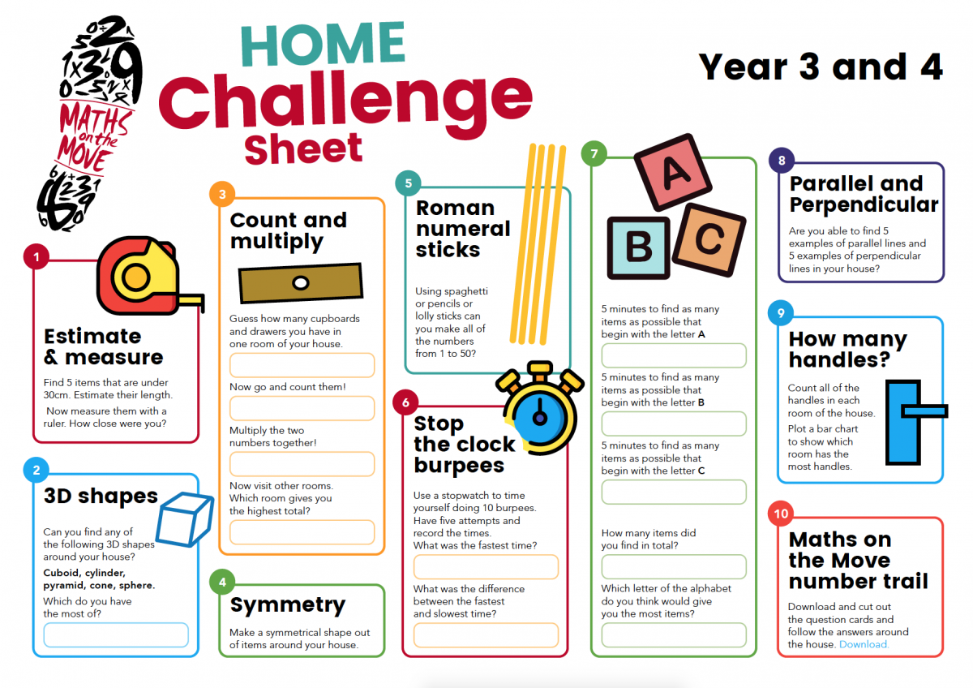

**Useful links and resources**

|  |  |  |
| --- | --- | --- |
| |  | | --- | | * [10-minute literary challenges](https://link.aceville.com/click/19956098.40544/aHR0cHM6Ly93d3cubGVzc29uYWJsZS5jb20vaG9tZS1sZWFybmluZz91dG1fc291cmNlPUxlc3NvbmFibGVOZXdzbGV0dGVyJnV0bV9tZWRpdW09MjAyMDA0MDgmdXRtX2NhbXBhaWduPUhvbWVMZWFybmluZw/5e1ae6da773f846b431e7884K9e1ba315) | | <https://www.headstartprimary.com/> | |
| * Oak National Academy – Online lessons, step by step activities covering a range of subjects for a range of ages. <https://www.thenational.academy/> * BBC Bitesize Daily online lessons for specific year groups covering all curriculum subjects.   <https://www.bbc.co.uk/bitesize> |
| |  | | --- | | * [500 virtual museum tours](https://link.aceville.com/click/19956098.40544/aHR0cHM6Ly93d3cubGVzc29uYWJsZS5jb20vaG9tZS1sZWFybmluZz91dG1fc291cmNlPUxlc3NvbmFibGVOZXdzbGV0dGVyJnV0bV9tZWRpdW09MjAyMDA0MDgmdXRtX2NhbXBhaWduPUhvbWVMZWFybmluZw/5e1ae6da773f846b431e7884L9e1ba315) | | <https://artsandculture.google.com/> | |
|  |
| |  |  | | --- | --- | | * [Free online books, videos and games with BookTrust HomeTime](https://link.aceville.com/click/19956098.40544/aHR0cHM6Ly93d3cubGVzc29uYWJsZS5jb20vaG9tZS1sZWFybmluZz91dG1fc291cmNlPUxlc3NvbmFibGVOZXdzbGV0dGVyJnV0bV9tZWRpdW09MjAyMDA0MDgmdXRtX2NhbXBhaWduPUhvbWVMZWFybmluZw/5e1ae6da773f846b431e7884M9e1ba315)   <https://www.booktrust.org.uk/> | | |  | |  | | --- | | * [Free primary maths resources for Years 1-6](https://link.aceville.com/click/19956098.40544/aHR0cHM6Ly93d3cubGVzc29uYWJsZS5jb20vaG9tZS1sZWFybmluZz91dG1fc291cmNlPUxlc3NvbmFibGVOZXdzbGV0dGVyJnV0bV9tZWRpdW09MjAyMDA0MDgmdXRtX2NhbXBhaWduPUhvbWVMZWFybmluZw/5e1ae6da773f846b431e7884W9e1ba315) | | <https://masterthecurriculum.co.uk/> | | |  |  | |  | |  | | --- | | * [Free ebooks for children aged 3-11 from Oxford University Press](https://link.aceville.com/click/19956098.40544/aHR0cHM6Ly93d3cubGVzc29uYWJsZS5jb20vaG9tZS1sZWFybmluZz91dG1fc291cmNlPUxlc3NvbmFibGVOZXdzbGV0dGVyJnV0bV9tZWRpdW09MjAyMDA0MDgmdXRtX2NhbXBhaWduPUhvbWVMZWFybmluZw/5e1ae6da773f846b431e7884X9e1ba315) | | <https://www.oxfordowl.co.uk/> | | |  |  | |  | |  | | --- | | * [Free cross-curricular primary resources from National Geographic Kids](https://link.aceville.com/click/19956098.40544/aHR0cHM6Ly93d3cubGVzc29uYWJsZS5jb20vaG9tZS1sZWFybmluZz91dG1fc291cmNlPUxlc3NvbmFibGVOZXdzbGV0dGVyJnV0bV9tZWRpdW09MjAyMDA0MDgmdXRtX2NhbXBhaWduPUhvbWVMZWFybmluZw/5e1ae6da773f846b431e7884Y9e1ba315) | | <https://www.natgeokids.com/uk/> | | |  |  | |  | |  | | --- | | * [Comprehensive free website for parents to support home literacy learning](https://link.aceville.com/click/19956098.40544/aHR0cHM6Ly93d3cubGVzc29uYWJsZS5jb20vaG9tZS1sZWFybmluZz91dG1fc291cmNlPUxlc3NvbmFibGVOZXdzbGV0dGVyJnV0bV9tZWRpdW09MjAyMDA0MDgmdXRtX2NhbXBhaWduPUhvbWVMZWFybmluZw/5e1ae6da773f846b431e7884Z9e1ba315) | | <https://literacytrust.org.uk/> | | |  |  | |  | |  | | --- | | * [Pearson maths and English resources free of charge during school closures](https://link.aceville.com/click/19956098.40544/aHR0cHM6Ly93d3cubGVzc29uYWJsZS5jb20vaG9tZS1sZWFybmluZz91dG1fc291cmNlPUxlc3NvbmFibGVOZXdzbGV0dGVyJnV0bV9tZWRpdW09MjAyMDA0MDgmdXRtX2NhbXBhaWduPUhvbWVMZWFybmluZw/5e1ae6da773f846b431e7884a9e1ba315) | | <https://www.pearson.com/en-gb.html> | | |  | | |